MODULE 5
1. Generate a new variable to account for percentage of students responding to the teaching evaluation survey.
pereval = (students/allstudents)*100
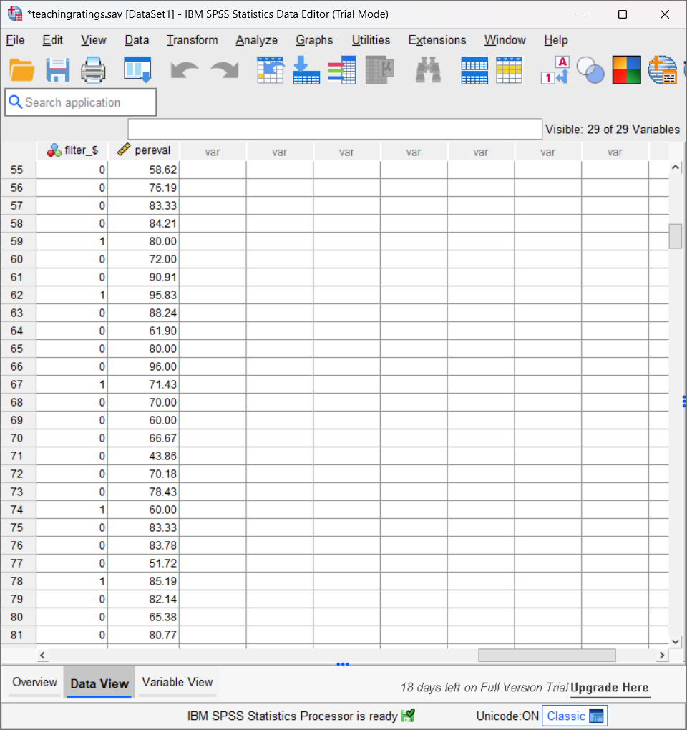
The percentage of students who responded to the teaching evaluation survey for each case.

2. Using the weighted data set, find the averages and standard deviations for the following: eval, beauty, and age

Descriptive Statistics
 | N | Mean | Std. Deviation
beauty | 463 | .0000 | .78865
age | 463 | 48.37 | 9.803
eval | 463 | 3.9983 | .55487
Valid N (listwise) | 463

After Adding the Weighted dataset

Descriptive Statistics
 | N | Mean | Std. Deviation
beauty | 1851 | .0206 | .79027
age | 1851 | 48.29 | 9.755
eval | 1851 | 4.0751 | .53068
Valid N (listwise) | 1851

3. Using the weighted data set, find the averages for the following: female, single_credit, upper_division. Interpret the findings.

Descriptive Statistics
 | N | Mean
female instructor | 1851 | .4109
upper division course | 1851 | .65
single credit course | 1851 | .07
Valid N (listwise) | 1851

4. Identify the unique records using the variable prof, compute the mean and standard deviation for age and beauty.

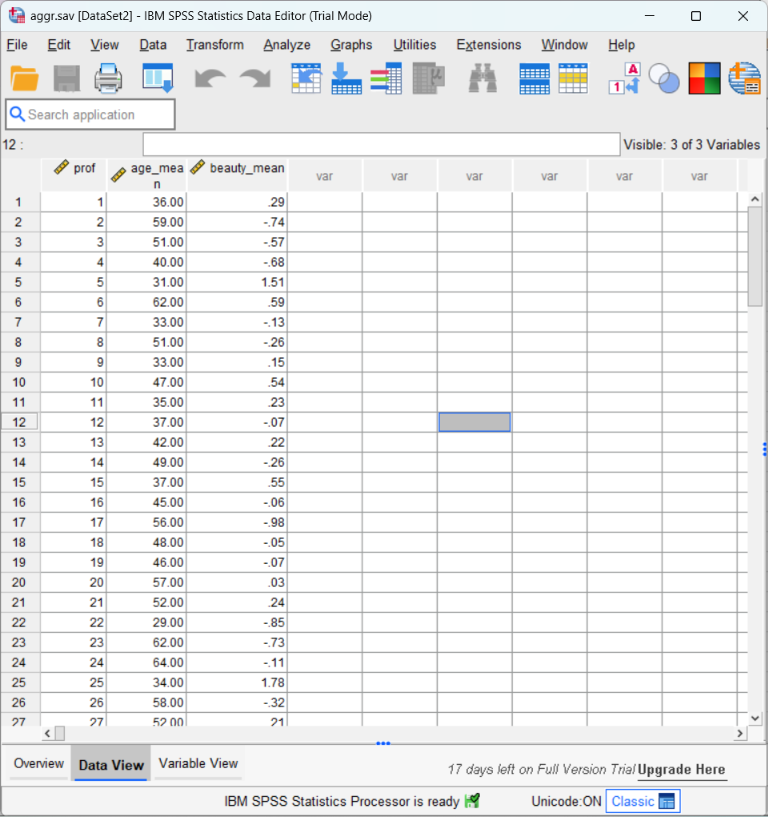

5. Using the entire data set, divide the sample into single_credit and more_credit courses. Repeat steps 2 and 4.

Descriptive Statisticsª
 | N | Mean | Std. Deviation
eval | 436 | 3.9658 | .54613
beauty | 436 | .0166 | .79750
age | 436 | 48.43 | 10.071
Valid N (listwise) | 436
a. credits = more

Descriptive Statisticsª
 | N | Mean | Std. Deviation
eval | 27 | 4.5222 | .42184
beauty | 27 | -.2681 | .57584
age | 27 | 47.37 | 3.078
Valid N (listwise) | 27
a. credits = single

